Stroke Risk Prediction from Routine Clinical Variables
Hoang Quang Huy, Dao Cong Khoi, Pham Minh Dung, Nguyen Chu Hieu
I. Introduction
A. Clinical Problem Formulation
Stroke occurs when blood flow to part of the brain is blocked (ischemic, the most common type) or a vessel ruptures (hemorrhagic), causing brain-cell death and lasting physical, communicative and cognitive disability. Our target population is adults screened in routine care; the public development dataset (n = 5,110) also contains 856 minors (16.8%, only 2 strokes), so special consideration will be paid to this problem in this research
The input space X consists of 10 routine variables: gender, age, hypertension, heart disease, marriage, work type, residence type, average glucose level, BMI and smoking status (the patient ID is excluded). The output Y is a binary stroke label (1 = stroke, 0 = no stroke). The task is therefore supervised, binary classification on tabular data with severe class imbalance (4.87% positives). The dataset does not state whether the label is a prior or a future event, so we treat the system as a risk-stratification screen rather than a diagnostic of an acute event.
B. Problem Statement and Clinical Urgencies
Stroke affects about 13 million people and kills about 5.5 million each year worldwide [1]. For Vietnam, it is reported that there occur roughly 200,000 new cases and 170 deaths per 100,000 people annually. Early symptoms (balance loss, vision changes, facial droop) are subtle, and damage can be limited if risk is recognized early. Existing tools are limited: risk calculators can miss sudden changes, imaging is costly and time-consuming, and functional assessments do not capture direct cardiovascular anomalies. A decision-support system that scores risk from inexpensive routine data could accurately and effectively point out who needs imaging and preventive treatment.
Asymmetric cost: false negative (FN) leaves a high-risk patient without blood-pressure, glucose or antithrombotic management, so the stroke, with its disability or death, may occur unprevented. A false positive (FP) triggers extra confirmatory tests, cost and anxiety, which are recoverable. FN is therefore the more costly error and we will favor sensitivity. Because 95.13% of patients are stroke-free, a model that always predicts “no stroke” reaches 95.1% accuracy while detecting nobody, so accuracy is not used. Our primary metrics are sensitivity (recall) at a fixed specificity and PR-AUC (chance level 0.049); secondary metrics might include ROC-AUC, F2-score and calibration.
II. Deep Literature Review
Table I summarizes the studies collected so far. A 2025 systematic review of 58 studies concludes that ensemble methods (Random Forest, XGBoost, stacking) give the highest accuracy for stroke occurrence (90.4–97.8%). It also notes high methodological heterogeneity that prevented a meta-analysis. Two studies use the public Kaggle stroke dataset. Dritsas and Trigka report AUC 0.989 for a stacking ensemble after applying SMOTE. Akinwumi et al. report ROC-AUC 0.836 on the same data, and all five of their models show poor recall despite about 95% accuracy. Three large studies use real-world cohorts or electronic health records. Gradient boosting reached AUROC 0.83–0.84 and was better calibrated than Cox models in 503,842 adults. Random Forest reached AUC 0.980 in 92,172 adults with 436 incident strokes. XGBoost reached AUC 0.922 in 57,671 hypertensive patients.
TABLE I. Literature comparison matrix (2020–2025).
Title | Authors | Dataset (name, size) | Method | Results | Key contribution | Limitations / bottlenecks
Machine learning techniques for stroke prediction:  A systematic review of algorithms, datasets, and regional gaps | Afeez Adekunle Soladoye, Nicholas Aderinto,  Mayowa Racheal Popoola, Ibrahim A. Adeyanju,  Ayokunle Osonuga, David B. Olawade | Synthesized datasets across all 58 included studies | Conducted a systematic review following PRISMA guidelines  and performed bibliometric analysis and qualitative/descriptive  data synthesis across prediction objectives, preprocessing  techniques, feature selection/extraction, and classification  algorithms | Ensemble Learning Methods (e.g., Random Forest, XGBoost, stacking) consistently achieved the  highest predictive performance for stroke occurrence, with accuracies ranging from 90.4% to 97.8%.  Deep Learning Architectures (e.g., CNN-biLSTM) excelled in biosignal and imaging applications,  achieving up to 96% accuracy for real-time EEG-based stroke detection | Provides a comprehensive, end-to-end mapping of the machine learning  pipeline for stroke prediction (data acquisition, preprocessing, feature  selection, classification, and evaluation) | High methodological heterogeneity across included studies  precluded a quantitative meta-analysis, restricted to  open-access, English-language journal articles, potentially  introducing publication bias
Stroke Risk Prediction with Machine Learning Techniques | Elias Dritsas, Maria Trigka | Filtered subset of the public Kaggle Stroke Prediction Dataset. This  subset contains Consists of 3,254 participants with 10 predictor  features (age, gender, hypertension, heart disease, ever married,  work type, residence type, average glucose level, BMI, smoking  status) and 1 target variable | Filtered raw dataset >> Addressed severe class imbalance  using SMOTE >> Computed feature importance >> Evaluated  individual classifiers >> Implemented ensemble techniques >>  Evaluated performance | The Stacking classification method achieved the highest performance across all evaluation metrics:  AUC: 98.9% (0.989), Accuracy: 98.0% (0.98), F-Measure: 97.4% (0.974), Precision: 97.4% (0.974),  Recall: 97.4% (0.974) | Proposes a heterogeneous stacking framework (Naive Bayes + RF + J48 + Rep  Tree $\rightarrow$ LR) that outperforms individual classifiers and hard majority  voting, identifies Age, BMI, and Average Glucose Level as the primary risk  factors for stroke occurrence | Relies on a public dataset (Kaggle) with limited size and specific  features, rather than rich clinical health records directly from  a hospital or medical institute, does not incorporate  physiological time-series, biological markers, or diagnostic  imaging
Evaluating machine learning models for stroke prediction based on clinical variables | Patrick O. Akinwumi, Stephen Ojo, Thomas I. Nathaniel,  James Wanliss, Olukayode Karunwi,  and Mercy Sulaiman | Publicly available Kaggle Stroke Prediction Dataset  consisting of 5,110 patient records with 11 predictor  features | Evaluated five supervised machine learning  algorithms: Logistic Regression (LR), Random  Forest (RF), Gradient Boosting Machine (GBM),  Support Vector Machine (SVM), and K-Nearest  Neighbours (KNN) | Logistic Regression achieved the highest cross-validation mean accuracy (95.11%)  and highest ROC-AUC score (0.8362 / 0.837), SVM achieved 95.12% accuracy but  a lower ROC-AUC of 0.60 | Demonstrates that standard evaluation metrics like global accuracy and ROC-  AUC can be misleading in rare-event medical prediction  Establishes that simple data-level balancing (Random Over-Sampling) alone is  insufficient to ensure model recall in minority event detection | Critically Low Model Recall/Sensitivity, Dataset  Underrepresentation and absence of multimodal  data
Stroke risk prediction using machine learning: a prospective cohort study of  0.5 million people | Robert Clarke (Corresponding  Author), Michael Chen, Thomas Zhang, Dan Cui,  Zhengming Chen, and members of the China  Kadoorie Biobank Collaborative Group | Evaluated 503,842 adults (205,293 men and 298,549 women) aged  35–74 with no prior history of stroke or transient ischemic attack at  baseline | Evaluated survival models (Cox Proportional  Hazards, [RSF]) alongside classification models  [LR], [SVM], [GBT], [MLP] and then bench mark  against 2017 Framingham Stroke Risk Profile (FSRP) | Gradient Boosted Trees (GBT) was the overall best single ML model, achieving high discrimination  (AUROC ~0.83–0.84) and superior calibration compared to conventional Cox models | Demonstrates that ML algorithms (especially GBT) substantially improve  calibration and short-term risk prediction over traditional Cox and Framingham  scores in a massive contemporary population of 0.5 million Chinese adults | Omission of Atrial Fibrillation (AF), Exclusion of Right-  Censored Data, Need for External Validation
Development and validation of a stroke risk prediction model using regional  healthcare big data and machine learning | Yunxia Duan, Rui Wang, Yu-Mei Sun, Wendi Zhu, Yi Li,  Na Yu, Yu Zhu, P. Shen, Hongyu Sun | CHERRY regional EHR platform in Yinzhou, China, covering 2015–2021  ; 92,172 adults aged 18–75 with 436 incident stroke cases | Retrospective cohort study comparing logistic regression, decision tree, random forest, XGBoost, and back-propagation neural network models | Random forest performed best with validation AUC 0.980, accuracy 0.919, precision 0.912, recall 0.929, and F1 0.921 | It developed a community-based Chinese stroke risk model from large-scale  regional healthcare data and showed ML outperformed conventional logistic  regression | The model had only internal validation, used a single-region  dataset, relied on SMOTE for class imbalance, and lacked deeper  explainability analysis such as SHAP
Accurate Prediction of Stroke for Hypertensive Patients Based on Medical Big  Data and Machine Learning Algorithms: Retrospective Study | Yu-Jie Yang, Jing Zheng, Zhenzhen Du, Ye Li, Yunpeng  Cai | 57,671 hypertensive patients from the Shenzhen Health Information  Big Data Platform | XGBoost, random forest, SVM, logistic regression | The tree-based integration algorithm extreme gradient boosting achieved the optimal performance with an area under the receiver operating characteristic curve of 0.9220, surpassing the other 3 traditional machine learning algorithms. | A key contribution was adding multitemporal trend features from repeated  follow-up records, not just baseline variables. These trend variables materially  contributed to prediction, including pulse pressure difference, heart-rate mean,  and blood-pressure variability measures | he study was retrospective, had substantial missing data,  excluded many patients during screening, and used stratified  sampling to handle class imbalance . Laboratory markers were  sparse enough that some biochemical variables in traditional  scales could not be included

A. Research Gaps
Gap 1: evaluation protocol drives the headline numbers. On the same public data, one reports AUC 0.989 after applying SMOTE to the whole dataset before 10-fold CV, whereas another reports ROC-AUC 0.836 with poor recall. One paper reports AUC 0.98 without a split description in its abstract, and splits randomly by admission. Synthetic or repeated records can end up on both sides of a split, so such scores are likely optimistic.
Gap 2: no external or temporal validation for tabular stroke-risk models. Most papers evaluate internally, while the few registry studies test on later or foreign cohorts.
Gap 3: sensitivity is not the target. For all papers, accuracy and AUC dominate. Explanations are post-hoc SHAP or absent, and none is checked against clinical plausibility. Our project addresses these gaps with (i) splitting before any resampling, with resampling inside CV folds only, (ii) FN-oriented metrics and (iii) SHAP in the later stage.
B. Baseline Models
We will benchmark against a majority-class dummy classifier, class-weighted Logistic Regression, Random Forest, SVM (all three already prototyped); and potentially gradient boosting (XGBoost/LightGBM).
III. Dataset and Exploratory Data Analysis
A. Dataset Description
We use the Kaggle “Stroke Prediction Dataset”: a single CSV of 5,110 records and 12 columns (ID, 10 features, label). The uploader does not disclose the originating hospital, country or collection period, and Kaggle restricts use to educational purposes. Data are tabular, so sampling frequency and image resolution do not apply. Three features are numeric (age, glucose, BMI), two binary clinical (hypertension, heart disease) and five categorical.
From a demographic perspective: the mean age is 43.2 years (SD 22.6; median 45; range 0.08–82), 58.6% of patients are female (2,994 F, 2,115 M, 1 “Other”), and stroke rates are similar by gender (F 4.71%, M 5.11%). No ethnicity or region is given, so fairness across ethnic or regional groups cannot be assessed. The sample is also younger and more female than a typical stroke population, so calibration may not transfer to older Vietnamese patients, whose median onset is 60–69 years (slide 5).
B. Feature Analysis and Class Profiles
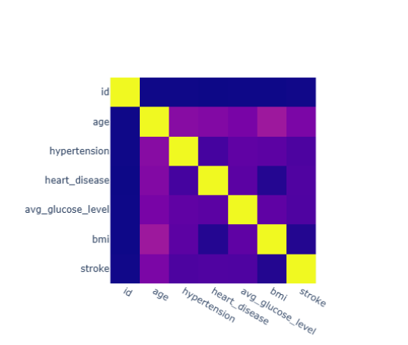
Fig. 1 shows the correlation matrix). Age has the strongest association with stroke (r = 0.245), followed by heart disease (0.135), glucose (0.132), hypertension (0.128) and marriage(0.108, largely an age proxy). BMI (0.042), gender (0.009) and residence (0.015) are weak. Stroke patients are much older (median 71 vs 43; 72.7% are ≥ 60) and show a second glucose mode near 200 mg/dL. Table II gives class-wise profiles, and Fig. 3a shows stroke rates by risk factor (hypertension 13.3% vs 4.0%; heart disease 17.0% vs 4.2%; odds ratios 3.7 and 4.7).

Fig. 1. Correlation matrix of numeric and encoded features and the stroke label (n = 5,110).
TABLE II. Class-wise profile (median [IQR] or %)
Feature | No stroke (n = 4,861) | Stroke (n = 249)
Age, median [IQR] | 43 [24–59] | 71 [59–78]
Glucose, mg/dL | 91.5 [77.1–112.8] | 105.2 [79.8–196.7]
BMI, kg/m² | 28.0 [23.4–33.1] | 29.7 [26.4–33.7]
Hypertension, % | 8.9 | 26.5
Heart disease, % | 4.7 | 18.9
Ever/former smoker, % | 32.1 | 45.0
Self-employed, % | 15.5 | 26.1
Male, % | 41.3 | 43.4
BMI missing, % | 3.3 | 16.1

C. Class Imbalance
There are 4,861 non-stroke and 249 stroke patients (95.13% vs 4.87%), an imbalance ratio of 19.5:1 (Fig. 2a) and a null accuracy of 0.951. IDs are unique and there are no duplicated rows, so sample level equals patient level (one row per patient), though repeated persons under different IDs cannot be excluded. Stroke is almost absent below age 40 (8 of 2,170 patients, 0.4%), so imbalance is strongly age-dependent.
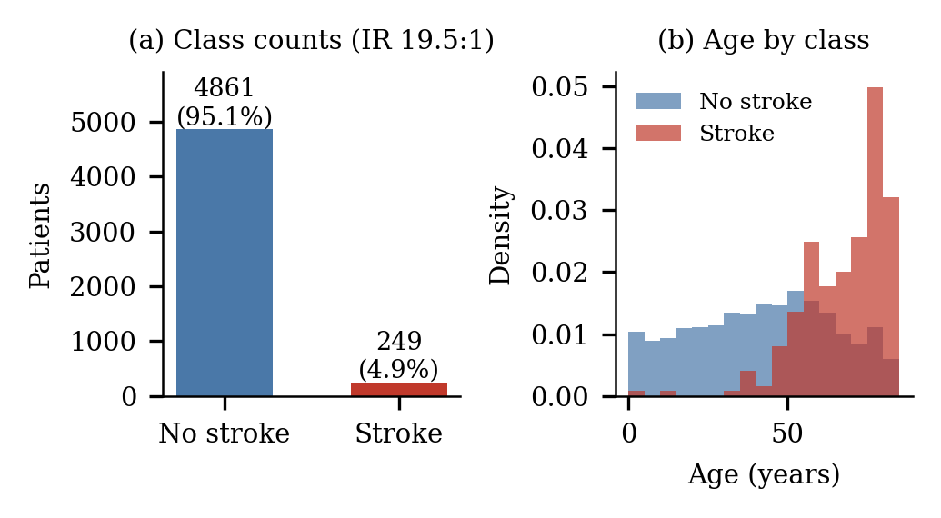
Fig. 2. (a) Class counts; (b) age distribution by class.
D. Missing Data and Data Quality
Only BMI has coded missing values: 201 records (3.93%). Missingness is informative: 16.1% of stroke patients lack BMI versus 3.3% of non-stroke patients, so the stroke rate among missing-BMI records is 19.9% against 4.3% when BMI is observed (Fig. 3b). Dropping or mean-imputing them would bias results; we plan train-only imputation plus a missingness indicator. Our current notebook imputes BMI with a decision-tree regressor on age and gender before splitting, which we will move inside the training fold.
Smoking status hides a second missingness: 1,544 records (30.2%) are “Unknown”, of which 682 are minors. Other quality issues are implausible BMI (max 97.6; 13 records > 60), glucose up to 271.7 mg/dL (434 records ≥ 200), one “Other” gender and 687 “children” work-type records that act as an age proxy. Work type, marital status and smoking status are therefore confounded with age.
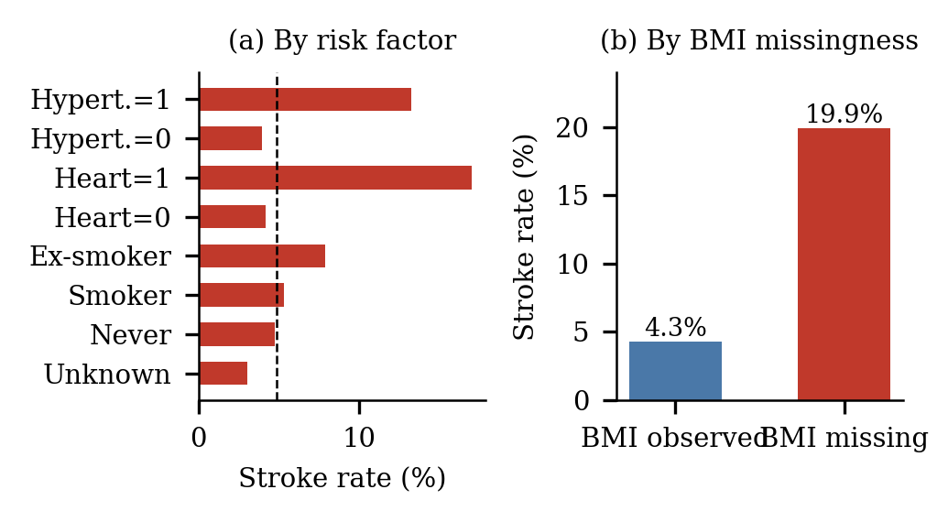
Fig. 3. (a) Stroke rate by risk factor (dashed line = overall 4.87%); (b) stroke rate by BMI missingness.
IV. Preprocessing and Leakage Control
A. Preprocessing and Split
Text categories (gender, marital status, work type, residence, smoking status) are encoded as integers. The data are split 80/20 and SMOTE is applied to the training part only, so the 1,022 test patients keep their natural prevalence; this resampling order is correct. The test set holds 62 of the 249 strokes (6.1% vs 4.9% overall), which suggests the split is not stratified [confirm]. Because each ID occurs once, record-level and patient-level splitting coincide and no patient can appear in two sets.
B. Leakage Assessment and Planned Corrections
Three issues remain before this step meets the zero-leakage rule. (1) Imputation and scaling must be fitted inside the training fold [confirm in the current notebook]. (2) Tuning and the choice of the final model currently use the test set; we will add a validation set or nested stratified CV and use the test set once. (3) Integer coding imposes a false order on nominal variables; we will use one-hot encoding. All steps will be wrapped in an imblearn Pipeline (imputer → encoder → scaler → SMOTE → classifier) so they are refitted per fold. The CSV has no patient identifier other than the unique ID, which is used for the overlap check.
Preprocessing script: “https://github.com/daokhoi1106-lab/Machine_learning”

Group Contribution and AI Usage Statement
TABLE III. Group contributions
Member | Student ID | Main contributions
Dao Cong Khoi | 202414847 | Information research, EDA analysis
Pham Minh Dung | 202414833 | Information research, models consideration
Nguyen Chu Hieu | 202414837 | Information researching, EDA analysis

AI usage. Claude - drafting and condensing the report from the group’s slides and notebook; Consensus: initial literature search; NotebookLM: summarizing research papers.

References

[1] | N. A. M. R. P. I. A. A. O. D. B. O. Afeez Adekunle Soladoye, Machine learning techniques for stroke prediction: A systematic review of algorithms, datasets, and regional gaps, International Journal of Medical Informatics , 2025.
[2] | M. T. Elias Dritsas, Stroke Risk Prediction with Machine Learning Techniques, Sensors (MDPI), 2022.
[3] | S. O. T. I. N. J. W. O. K. a. M. S. Patrick O. Akinwumi, Evaluating machine learning models for stroke prediction based on clinical variables, Frontiers in Neurology, 2025.
[4] | M. C. T. Z. D. C. Z. C. a. m. o. t. C. K. B. C. G. Robert Clarke, Stroke risk prediction using machine learning: a prospective cohort study of 0.5 million people, Journal of the American Medical Informatics (JAMIA), Volume 28, Issue 8, Pages 1719–1728, 2021.
[5] | R. W. Y.-M. S. W. Z. Y. L. N. Y. Y. Z. P. S. H. S. Yunxia Duan, Development and validation of a stroke risk prediction model using regional healthcare big data and machine learning, International Journal of Nursing Sciences , 2025.
[6] | J. Z. Z. D. Y. L. Y. C. Yu-Jie Yang, Accurate Prediction of Stroke for Hypertensive Patients Based on Medical Big Data and Machine Learning Algorithms: Retrospective Study, JMIR Medical Informatics, 2021.

